Tableau Cloud – Appspace
Digital Signage Connection
Solution Architecture Document
Document Type | Solution Architecture Document
Audience | Solution Architects, Tableau/Appspace Admins
Owner | Data & BI Support Team
Version | 2.0
Last Updated | 18 August 2026

1. Architecture Overview
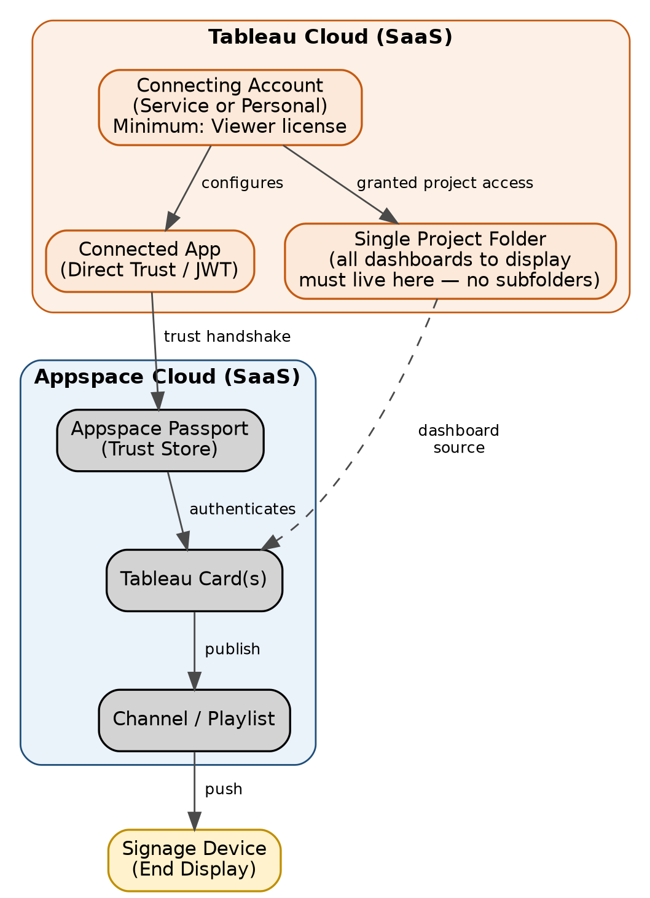
Figure 1: End-to-end architecture — Tableau Cloud to signage display

2. Key Access & Licensing Requirements
⚠ Must be confirmed before configuration begins
1. The connecting account (service account or personal account) must have a Tableau Cloud license — minimum Viewer level — to authenticate the integration.
2. That same account must be explicitly granted access to the specific project/folder containing the dashboards that will be shown on Appspace cards.
3. Appspace cannot traverse into subfolders. Every dashboard intended for display must sit in a single, flat Tableau project folder — no nested folder structures.

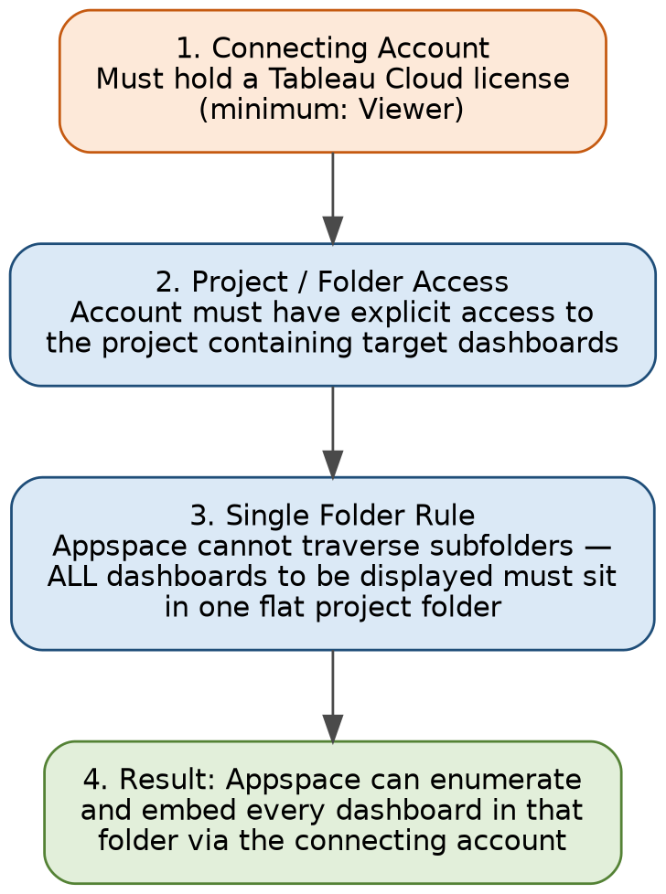
Figure 2: Access and licensing dependency chain

3. Component Summary
Component | Role | Hosting
Connecting Account | Authenticates the integration; must hold Viewer+ license and project access | Tableau Cloud
Project Folder | Single flat folder holding all dashboards to be displayed | Tableau Cloud
Connected App | Issues signed trust tokens (Direct Trust) for authenticated embed access | Tableau Cloud
Appspace Passport | Stores credentials; brokers the trust handshake with Tableau | Appspace Cloud
Tableau Card | Content object embedding a dashboard from the connected folder | Appspace Cloud
Channel / Playlist | Schedules and pushes cards to signage devices | Appspace Cloud
Signage Device | Renders the published dashboard content | Edge – Corporate Network

4. Deployment & Network Topology
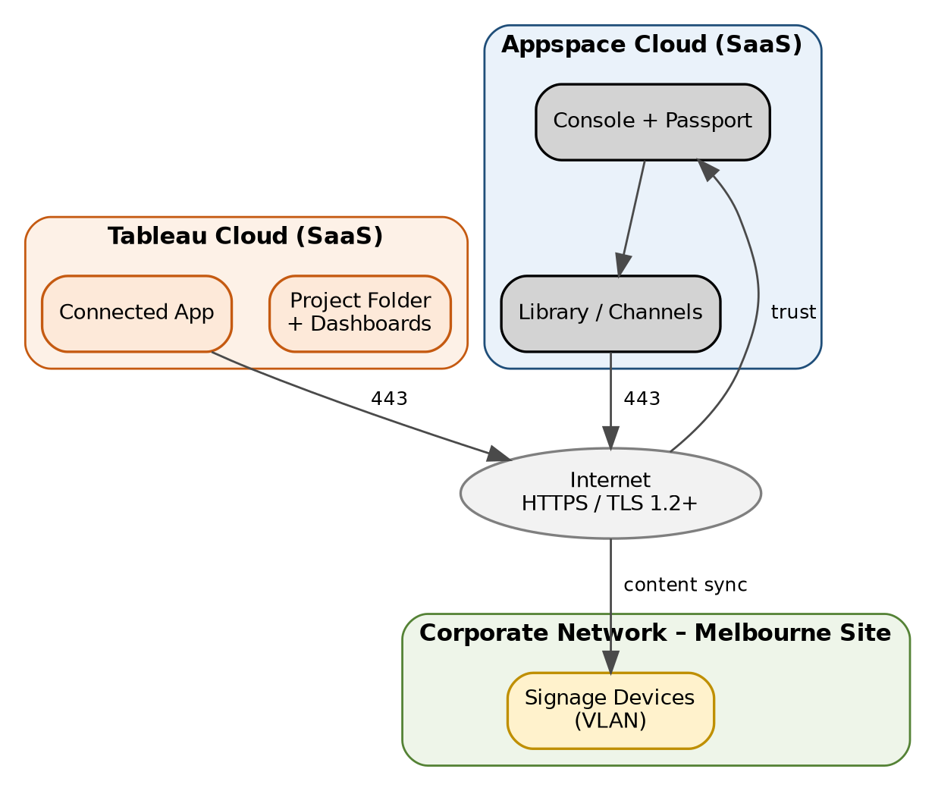
Figure 3: Deployment and network topology
- Both platforms are fully SaaS-hosted — no on-premises server component required.
- Outbound HTTPS (443) only, from the signage device VLAN to Appspace, and from Appspace to Tableau Cloud.
- No direct network path is required between signage devices and Tableau Cloud — Appspace proxies all dashboard content.

5. Security Notes
- Use Private Dashboard mode (Direct Trust) only — avoid Public Dashboard/URL mode for any internal data.
- Scope the connecting account and Connected App to the minimum required project — avoid site-wide access.
- Rotate Connected App credentials per your organization's key-rotation policy.
- Restrict edit access to the Appspace Passport configuration to Appspace Account Owners only.

6. Known Constraints
- Only Tableau dashboards are supported — Tableau reports cannot be embedded.
- Appspace cannot browse subfolders — restructure Tableau projects to keep signage-bound dashboards in one flat folder.
- Dashboards are not responsive inside the card — design/size dashboards for the target display resolution.

7. References
- Appspace Community – Cards: Display Tableau Dashboard: community.appspace.com/cards-134/cards-display-tableau-dashboard-627
- Tableau Help – Configure Connected Apps with Direct Trust (help.tableau.com)
- Tableau Help – Site Roles and License Types (help.tableau.com)

